**Source Code**

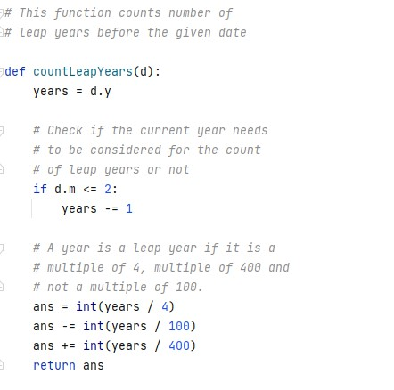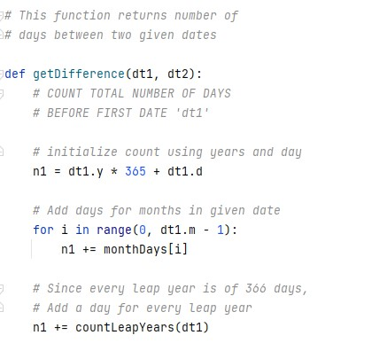

**Output Screen**

